Bank Management System - Test Case Report (Detailed)
1. Create Account - Valid
Input: Valid inputs with correct OTP
Expected Output: Account created successfully
Example: Example: User enters correct OTP (e.g., 1234) → Account is created. 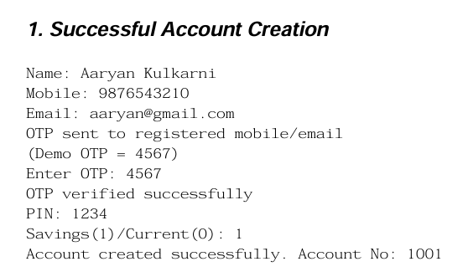
2. Create Account - Wrong OTP
Input: Wrong OTP entered
Expected Output: Account creation cancelled
Example: Example: OTP sent = 5678, user enters 1111 → Account will not be created.
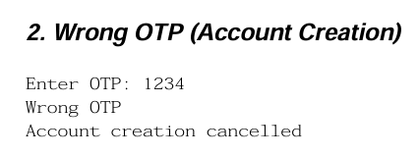
3. Deposit - Negative Amount
Input: Amount = -500
Expected Output: Invalid amount
Example: Example: User enters -500 → System rejects the transaction.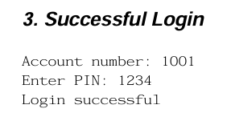
4. Deposit - Valid
Input: Amount = 2000
Expected Output: Deposit successful
Example: Example: User deposits 2000 → Balance increases.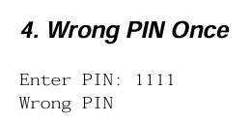
5. Withdraw - Insufficient Balance
Input: Withdraw > balance
Expected Output: Invalid amount
Example: Example: Balance = 1000, withdraw = 2000 → Transaction denied.